Residential Education Service

Sandwell
Metropolitan Borough Council
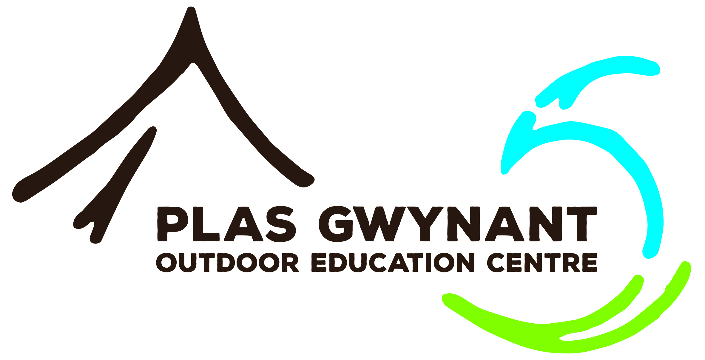
Plas Gwynant
Outdoor Education Centre
Dear Colleague

Thank you for agreeing to accompany a course to Plas Gwynant and we trust you will enjoy your visit.

All courses are run on a joint basis between yourselves and staff permanently based at the Centre in order to make maximum use of the opportunities we are able to provide. You will be accommodated in ensuite bedrooms near to the pupils.

During the course you will be able to make and receive telephone calls on the Centre’s line for which you will need to pay at the office before you leave. Staff have access to WiFi during their stay.

On activity courses Plas Gwynant staff will take responsibility for the technical input and all safety issues. There are obvious benefits to both yourself and the students if you join in the activities. The authority’s minibus regulations also require that two adults are in each minibus and we may ask you to accompany a particular group for this reason. We would be grateful if all accompanying staff would complete one of our medical and consent forms. You will not have to take part in any activity you are not happy with and the Centre can provide all technical equipment including waterproofs, boots and rucksacks. You will also need the clothing listed on the student kit list.

The Centre operates a daily timetable. We expect students to be woken between 7.15 a.m. and 7.30 a.m. and to undertake a small job contributing towards the maintenance and cleanliness of the Centre before breakfast at 8.20 a.m. After breakfast students make their packed lunch and there is then a brief staff meeting to discuss the previous evening and finalise the day’s activities. Staff order their packed lunches which are made by the kitchen staff. Activities continue until about 4.00 p.m. when tea and cakes are provided in the staff and dining rooms.

Dinner is usually at 6.00 p.m. and you will eat with the students, but on a separate table. Specialist diets can be catered for. We ask that you take a major share of responsibility for supervision at mealtimes to ensure continuity throughout the course.

A member of Plas Gwynant staff will be on duty each evening and remain on site overnight. Students’ bedtime is arranged in consultation with yourselves usually around 10.30 p.m. with ‘lights out’ half an hour later.

If you have any further questions regarding your visit to the Centre please do not hesitate to telephone. We look forward to working with you.

